**UNH SEDS**

**Final Project Report**

ME 756 Spring 2018



Reilly Webb

Nicholas Clegg

Kevin Bucher

Advisor: Professor Todd Gross

Table of Contents

List of Figures 3

List of Tables 3

List of Equations 4

Introduction 5

Abstract 5

Objectives of UNH SEDS 5

University Student Rocketry Competition 5

Goals 6

Constraints 6

Overall Rocket Assembly 6

COMPARISON OF TEST RESULTS 8

Static Test Fire Rig 8

Test Results 8

Test Comparisons 12

Flight Trajectory 14

Aether II 14

Further Testing 16

REDESIGN DETAILS 17

Improvement Cycle 17

Aerodynamic Models 18

Assumptions 18

Program Structure 19

Stability 19

Acceleration 21

Thrust 22

Mass 22

Drag 22

Trajectory 24

Model Verification 25

Nonlinear Optimization 27

Constraints 28

Finite Element Analysis 28

Model Rocket Class Iterations 29

Model Rocket v1 29

Model Rocket v2 29

Aether Class Iterations 29

Aether I 29

Aether II 30

Aether III 30

Aether IV 30

Aether V 30

DETAILED DESIGN 31

Aether VI 31

BILL OF MATERIALS 33

APPENDIX 35

References 35

# List of Figures

Figure 1. Rocket Components 7

Figure 2. Load Cell Calibration 9

Figure 3. STFR Setup 10

Figure 4. Booster Engine Response 10

Figure 5. Sustainer Engine Response 11

Figure 6. Engine Impulse vs Time 12

Figure 7. Experimental Data vs Cesaroni Supplied Data 13

Figure 8. Aether 2 Trajectory Comparison 14

Figure 9. Aether 2 Velocity Comparison 15

Figure 10. Aether 2 Stability 16

Figure 11. Improvement Cycle 17

Figure 12 Trapezoidal Fin Model 20

Figure 13. Aether IV Caliber 21

Figure 14. Aether IV Launch Simulation 25

Figure 15: Model verification using Aether IV rocket 26

Figure 16. Optimization of Aether VI Dimensions 27

Figure 17. Centering Ring FEA 28

Figure 18. Booster Fins 31

Figure 19. Sustainer Fins 32

Figure 20. Nose Cone 32

# List of Tables

Table 1. Surface Roughness 23

Table 2. Aether IV Apogee Predictions 26

# List of Equations

Equation 1 19

Equation 2 19

Equation 3 20

Equation 4 20

Equation 5 21

Equation 6 22

Equation 7 22

Equation 8 23

Equation 9 23

Equation 10 23

Equation 11 23

Equation 12 24

Equation 13 24

Equation 14 24

Equation 15 25

# Introduction

## Abstract

Members of UNH SEDS are designing, manufacturing, and launching a high powered multi-stage rocket for the SEDS University Student Rocketry Competition. Collegiate rocketry teams will be competing nationally in the Fall of 2018, with points awarded to the rockets that achieve the highest altitude, are fully recoverable, and are backed by the strongest design methodology. Since our team is working from the ground up, UNH SEDS has taken a "first principles" approach towards reaching these goals. Once fundamental aerodynamic relationships were studied and understood, they were implemented to create models of flight dynamics, drag, and stability. A static test fire rig was constructed to obtain experimental thrust curve data from the engines; further increasing the accuracy of our simulated trajectories. Driven by both manufacturing and competition constraints, our models were then used to optimize nose cone, body tube, and fin dimensions. Eight rocket iterations have been designed and launched. We have analyzed the flight data from each launch to continuously improve and learn important lessons out in the field that could not have been gathered from theory and simulations alone.

## Objectives of UNH SEDS

Students for the Exploration and Development of Space (SEDS) is a national, student-based organization that enables university students to get involved in space related projects. A chapter of SEDS has was founded at UNH in the Fall of 2017.

The mission of UNH SEDS is to provide a platform for students to form multi-disciplinary teams to pursue space-focused outreach, networking events, and engineering projects.

This year’s primary project is to design a rocket to compete in the University Student Rocketry Competition in the Fall of 2018. This work was completed by senior undergraduate members of SEDS for their senior project, however underclassmen were also involved by assisting with assembling the rocket prototypes.

## University Student Rocketry Competition

The USRC is an annual competition hosted by SEDS-USA to challenge students, to design, build, and launch a multi-stage rocket with a standardized altimeter to the highest possible altitude. The judging panel includes professionals within the aerospace industry. Winning teams will be awarded a cash prize as well as free attendance to the SEDS SpaceVision 2018 conference. Teams are able to launch at a field close to their university and witnessed by an independent party, although teams can also meet up to organize a regional launch. Points are awarded by the judges based on the following criteria:

### Goals

1. Design and launch a high-powered rocket to achieve **maximum altitude** (at least 3000 feet)
2. Implement a comprehensive recovery system that results in a fully reusable rocket

### Constraints

1. Total combined engine impulse must not exceed **640.0 N-s**
2. The rocket must have *at least* two propulsive stages
3. Time: Launch window closes **October 12th, 2018**
4. Budget: $4563.0 from ME department and Parents Association

## Overall Rocket Assembly

A section-view model of the rocket configuration is shown below in Figure 1. This is simply a high-level description of major components that will be frequently referenced throughout the remainder of the report.

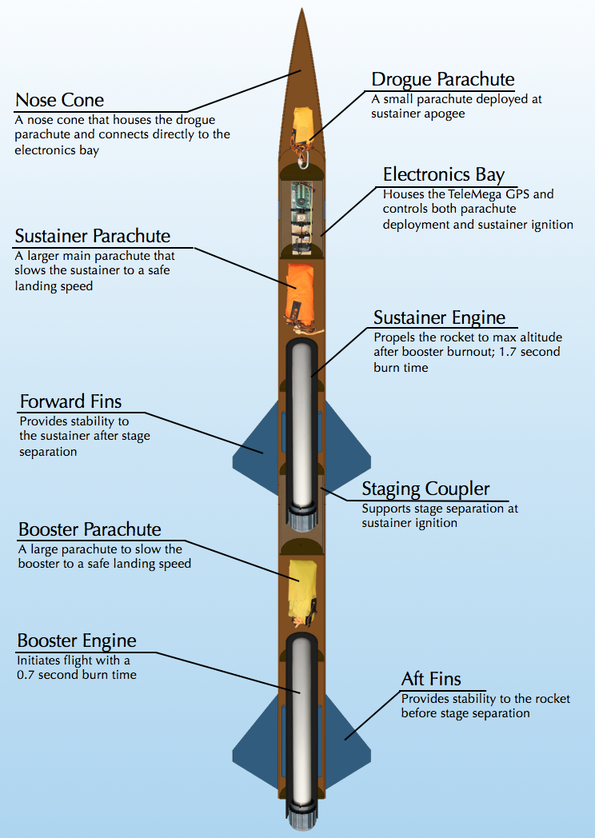

Figure 1. Rocket Components

Both engines are solid-propellant rocket motors manufactured by Cesaroni. Solid engines were chosen for simplicity and purchased instead of being custom built. Next year, SEDS will attempt to manufacture their own hybrid rocket engines.

The TeleMega GPS/Altimeter system used will be referenced as the flight computer. The flight computer, located in the electrical bay (e-bay), sends electrical signals at various preprogrammed instances. Current is sent to three individual ignitors; one that initiates the firing of the sustainer engine and two that light ejection charges for parachute deployment.

The booster engine is the first engine to fire; ignited by hand from a safe distance using a custom ignition controller. After the booster burns out, the sustainer engine fires. The ignition of the sustainer separates the booster body tube from the sustainer body tube. The booster parachute then deploys, carrying the booster body tube and booster engine safely to the ground.

The sustainer body tube continues upward until the rocket reaches a maximum altitude, where the flight computer no longer recognizes a change in pressure and triggers an ejection charge. The ejection charge pressurizes the area above the electrical bay, forcing off the nose cone and deploying the drogue parachute. The drogue is a small parachute that works to slow the decent of the rocket to a controlled speed. At a predetermined altitude, the flight computer will send a signal to another ejection charge located aft of the e-bay. This charge separates the sustainer body tube from the e-bay and deploys the main parachute; a much larger parachute that slows the rocket components considerably, preventing damage upon impact with the ground.

# COMPARISON OF TEST RESULTS

## Static Test Fire Rig

### Test Results

Both the booster stage and sustainer stage engines for the competition rocket were tested to ensure that the rocket will meet the required specifications. A static test fire rig (STFR) was used to experimentally obtain the thrust output of the engines. Engine data is available online from the manufacturer, but we wish to test the engines ourselves. In order to guarantee that the engines match the specifications online, we will compare the experimental data to the expected data.

The test setup consisted of a custom STFR, two 12V batteries, a 250 lb load cell, an AD620 Amplifier, two 100 kΩ resistors, a DATAQ and a laptop with SignalExpress. The batteries were used to supply -12V and +12V to the amplifier, and 6V to the load cell. The load cell was calibrated in lab using known weights, later allowing for a conversion from voltage to thrust (Figure 2).

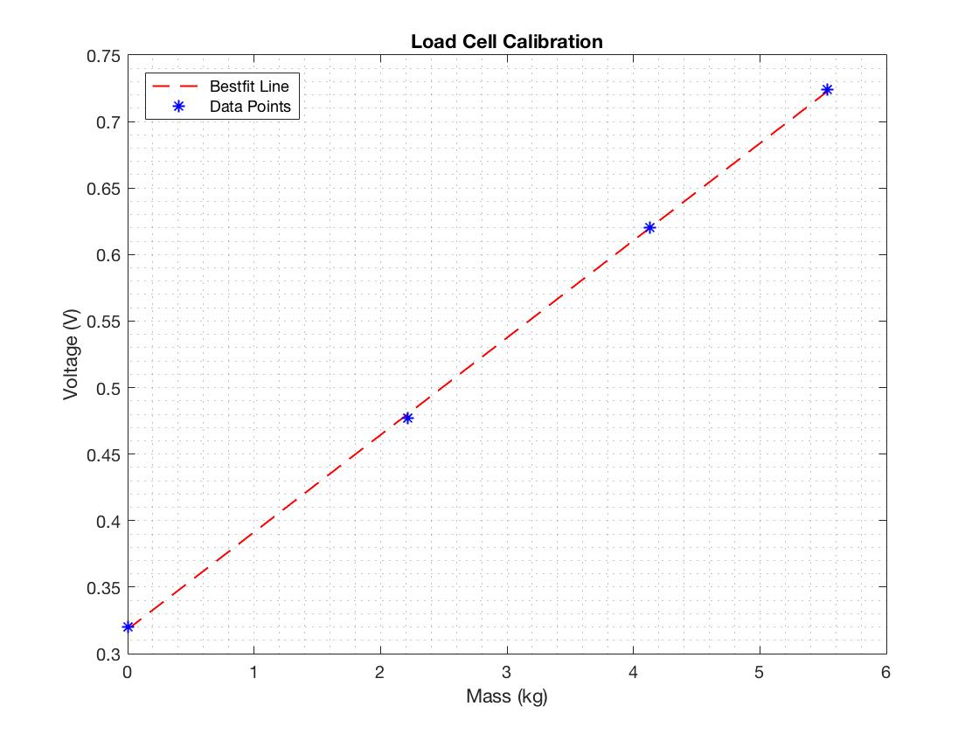

Figure 2. Load Cell Calibration

The test was conducted on Burley-Demeritt farm in Lee, NH. The STFR was placed on the ground and made as level as possible. This was made difficult by the surrounding snow. The electronics were placed on cardboard to keep them dry and undamaged. The experimental setup is seen in Figure 3.

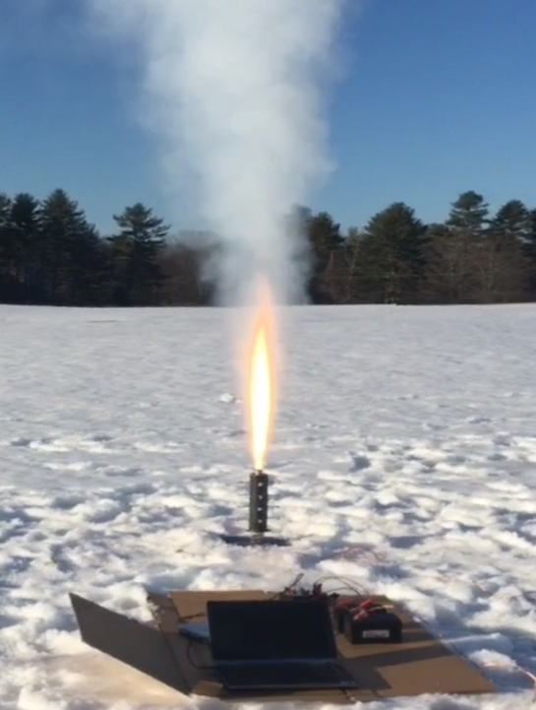

Figure 3. STFR Setup

Both the booster and sustainer engines were tested. Each time, the engine ignitor was inserted into the engine with the ignitor leads wired to the ignition controller and the controller to a power supply. The set screws along the test fire rig were tightened and the engine was made concentric with the cylindrical fixture. As one person recorded the data via Signal Express, the other ignited the engine. Both tests were successful. The booster thrust output can be seen in Figure 4.

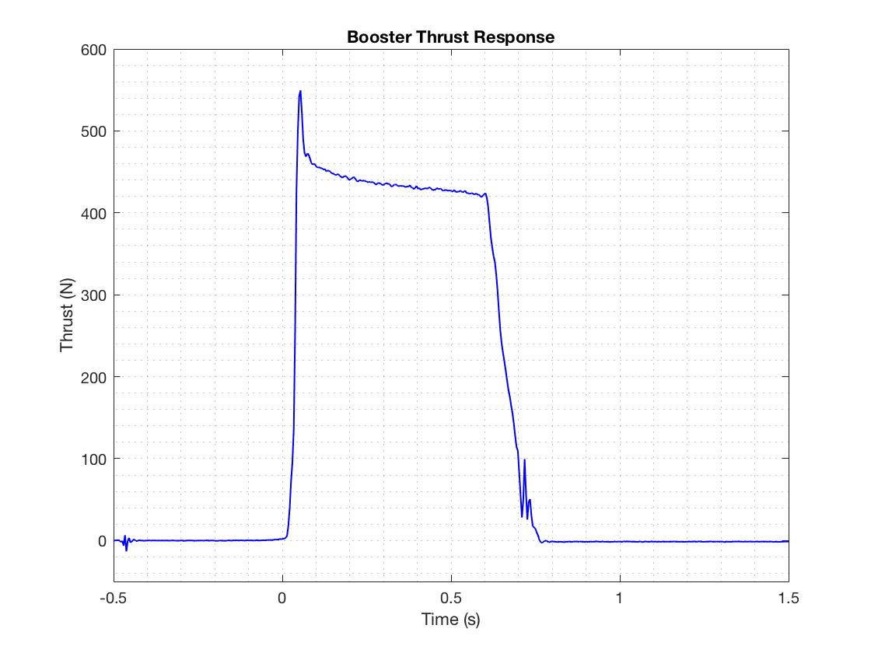

Figure 4. Booster Engine Response

The booster engine maxed out a 549.6 N. The booster engine used was a Cesaroni H399, which is rated by the manufacturer to have a maximum thrust of 545.8 N. The response was fairly smooth which leads us to believe our data acquisition setup was sufficient. The sustainer engine data, shown in Figure 5, was not quite as accurate.

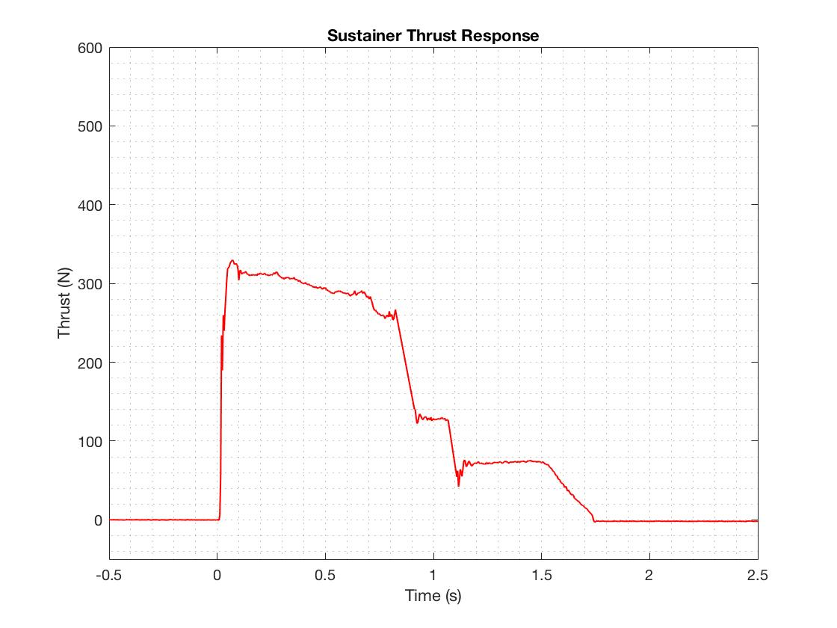

Figure 5. Sustainer Engine Response

The sustainer engine reached a max thrust of 330 N. The sustainer engine used was a Cesaroni I204 and is rated to have a maximum thrust of 356.8 N. The max thrust was off by about 27 N, and the remainder of the response contained a few spikes in the data that were treated as noise and filtered out.

The maximum combined impulse of our rocket cannot exceed 640 N-s as specified by competition guidelines. By integrating the thrust data, we acquired impulse as a function of time. Figure 6 shows the measured impulse of both engine types.

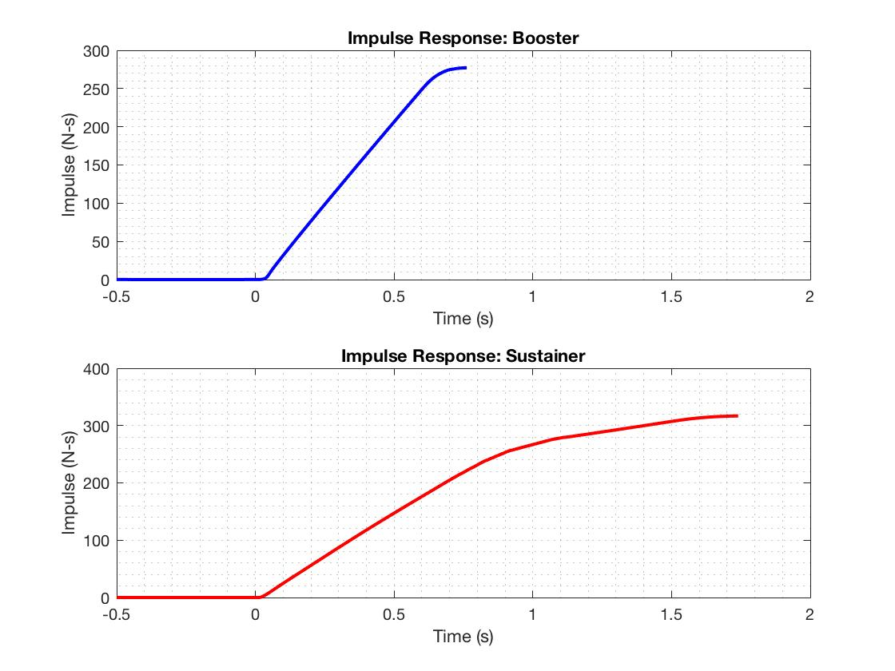

Figure 6. Engine Impulse vs Time

The booster engine was calculated to have a maximum impulse of 277.1 N-s while the sustainer engine was calculated to have a maximum impulse of 316.7 N-s. This would mean our total impulse is 593.8 N-s; well within competition guidelines.

### Test Comparisons

Data for both engine types was supplied by Cesaroni, and points were plotted on MATLAB to create a comparison between our measured data and the manufacturer’s supplied data. The compared thrust responses are displayed in the first two subplots of Figure 7.

There were a few attempts throughout the year to produce an analytical model for the thrust curve of our engines. However, after discussion with various UNH ME faculty member, it proved to be outside the scope of our project. Next year an analytical model will be much more valuable, as SEDS plans on designing our own hybrid engines.

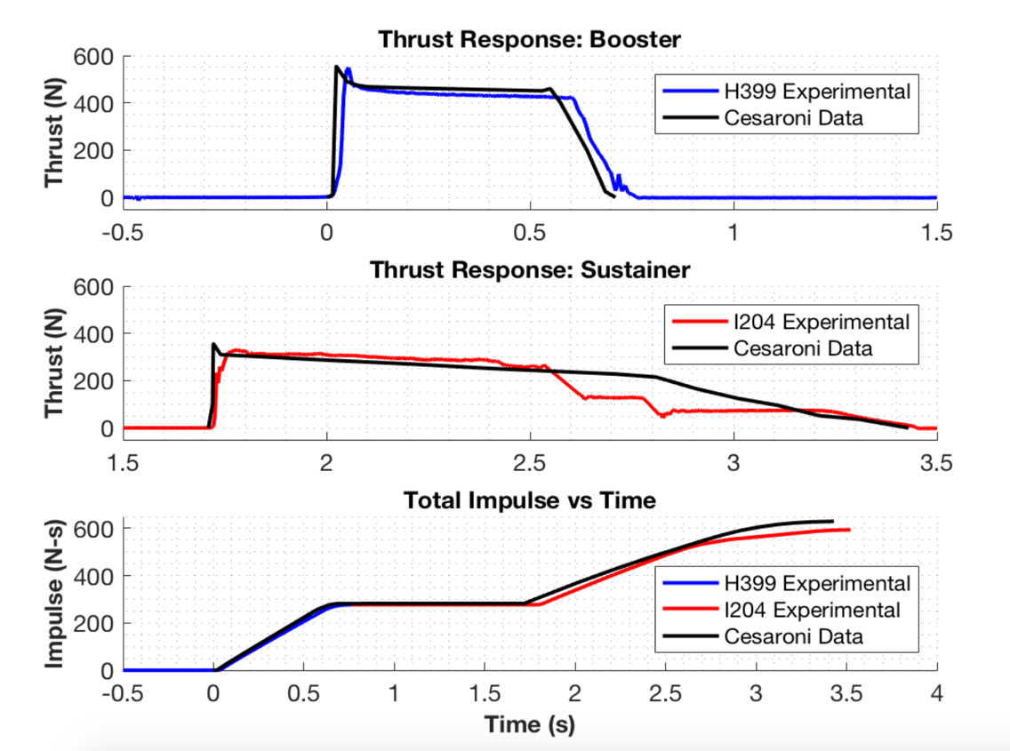

Figure 7. Experimental Data vs Cesaroni Supplied Data

The thrust comparison between the H399 booster engine data sets is very similar. The measured maximum thrust was off by only about 5 N, and both burn times were approximately 0.7 s. The supplied data response seems to show a nearly instantaneous maximum thrust, where as our measured data shows a slightly more delayed response. This could be due to limitations of the load cell, or slight variations in the rocket engines tested. Small differences in the packing of the solid propellant can have major effects on the characteristics of the engine.

The I204 sustainer engine burned for about 1.7 s during our tests; the time period for which it is rated to burn by Cesaroni. In addition to the aforementioned variations in maximum thrust, the rest of the measured sustainer response was not entirely accurate. In the first 0.75 s, the engine performed close to expected, gradually decreasing in thrust after reaching peak force. At about one second, we saw two spikes in the data that were clearly uncharacteristic of the engine response and we filtered out these data points. Still, we were left with an overall inaccurate response. While the engine was firing, we did notice there was a dip in the flame at about one second; leading the team to believe that there was a fault in the particular engine used. The exact same experimental method was used for both engines, and only the sustainer engine had these issues.

The third subplot in Figure 7 shows stacked booster and sustainer impulse data compared alongside Cesaroni data. The H399 booster and I204 sustainer are rated at 282.2 N-s and 347.7 N-s, respectively. This means that total impulse for our rocket was estimated to be 629.9 N-s. As mentioned previously, our experimental total impulse was found to be 593.8 N-s. Since the impulse is simply the integration of the thrust data, our inaccurate sustainer thrust threw off the total sustainer impulse value. Due to both time and money constraints, the team could not test another sustainer engine. We do plan to purchase more engines for testing in the future, and the STFR setup will be used to acquire a more accurate representation of the I204 sustainer thrust response and total impulse.

## Flight Trajectory

### Aether II

On the same day as the STFR experiments, the *Aether II* rocket was launched. The *Aether II* was the first rocket to give the team flight data. Previous rocket builds are highlighted in the Redesign Details section of the report. This was a single-stage launch, with the goal of perfecting the dual deploy recovery technique. The primary objective of *Aether II* was to accomplish this method of recovery, as it’s an effective way to prevent excessive crosswind induced drift for rockets with a high-altitude apogee. Based off of our MATLAB trajectory model, our expected altitude at apogee was around 760 m, making this rocket the ideal proof of concept test for dual deployment recovery. All *Aether* series rockets use Cesaroni G54 engines for the booster stage; a cheaper, lower impulse engine used for proof of concept.

Onboard the rocket was an electronics bay that housed a RRC3 barometric altimeter. This altimeter records height data from ground launch altitude with respect to time. A comparison of our MATLAB trajectory model and the recorded flight data can be seen in Figure 8.

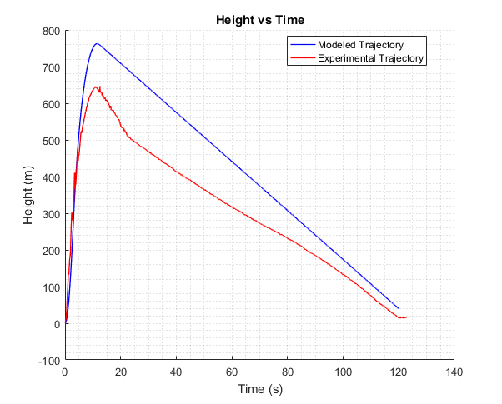

Figure 8. Aether 2 Trajectory Comparison

This data confirmed our suspicions that the dual deployment failed. At about 20 seconds into the launch, the ejection charge that is supposed to deploy only the drogue parachute also deployed the main parachute. This increased the drift distance of the rocket significantly (so much so that it drifted away from the field and got stuck in a tree). A comparison of the modeled velocity and recorded velocity in Figure 9 also shows that both parachutes deployed in a single event, as there is a constant falling velocity of around 7 m/s when there should be two distinct falling velocities for each deployment.

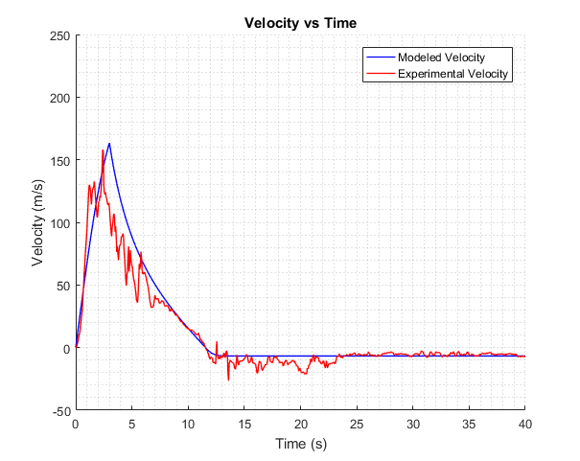

Figure 9. Aether 2 Velocity Comparison

The *Aether II*  trajectory model makes use of fundamental aerodynamic relationships between rocket drag, stability, and atmospheric conditions. A number of assumptions were made in constructing this model such as ignoring skin friction drag, crosswinds and updrafts, and assuming laminar flow. Also, the thrust data that was used to determine the acceleration during the engine burn was supplied by the manufacturer, and had not yet been confirmed experimentally by our static test fire rig. Our STFR was used to test the thrust of the higher impulse, competition grade engines. These factors may be the cause of deviations between the model and experimental data; especially in estimation of maximum altitude. Otherwise, the implementation of even the most fundamental aerodynamic relationships appears to give a reasonable estimation of rocket dynamics in-flight. Still, there was plenty of room for improvement of our simulations.

Predicting the stability of the rocket in flight was also a concern. A model to confirm passive stability for *Aether II* was also created in MATLAB. This was achieved by calculating the locations of the center of gravity and the center of pressure for the entire rocket. The center of gravity is the average location of the weight of the rocket, and the center of pressure is the point where the total sum of the surrounding pressure field acts on the rocket. The distance between the location of these two points determines the rocket’s passive stability, which is a measure of the rocket sensitivity to external aerodynamics forces such as cross-wind. The ideal spacing between these two points is to have the center of pressure 1-2 rocket diameters (calibers) aft of the center of gravity. Since the center of gravity changes as the fuel is consumed, the stability of the rocket also changes. This change is demonstrated by the change in caliber over time in Figure 10.

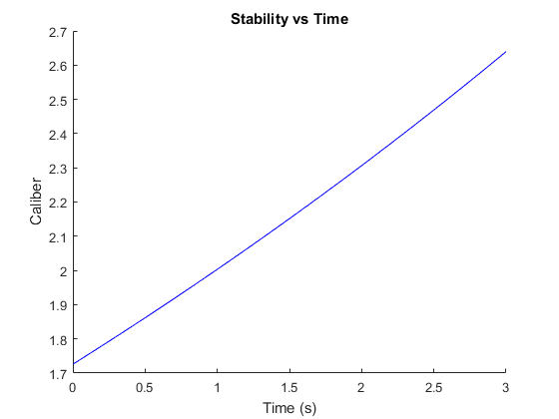

Figure 10. Aether 2 Stability

Since there is no way to quantify the stability of the rocket during flight, the best way we can confirm our model is to observe changes in the rocket’s attitude visually. *Aether II* appeared to fly relatively straight while leaving the launch rail, with little change to attitude during the engine burn. This observation suggests that our stability model was accurate, as it was predicted to have a high enough caliber to be conservatively stable.

### Further Testing

After the flight of *Aether II*, the team began development of a multi-stage rocket. *Aether III* was the first iteration to consist of dual-deployment and both booster and sustainer stages. Additionally, significant improvements were made to our flight simulations. Details of each *Aether* model are discussed in the Aether Class Iterations section of Redesign Details. The *Aether IV* launch results and simulations were highlighted on our URC poster. *Aether IV*’s simulation was the first to utilize our nonlinear optimization techniques that determined ideal dimensions to maximize altitude. Since the URC, we have constantly been working to improve, launching and recovering *Aether V* and later this week launching *Aether VI*.

The following section of the report will highlight each individual rocket iteration, describe our developmental process, and explain, in great detail, our improved MATLAB simulations. Unlike many senior design projects, rocketry requires constant redesign; testing and analyzing results each time, learning from successes and failures alike. Redesign Details will continue to discuss flight test results and how they compared to our MATLAB and OpenRocket models.

# 

# REDESIGN DETAILS

## Improvement Cycle

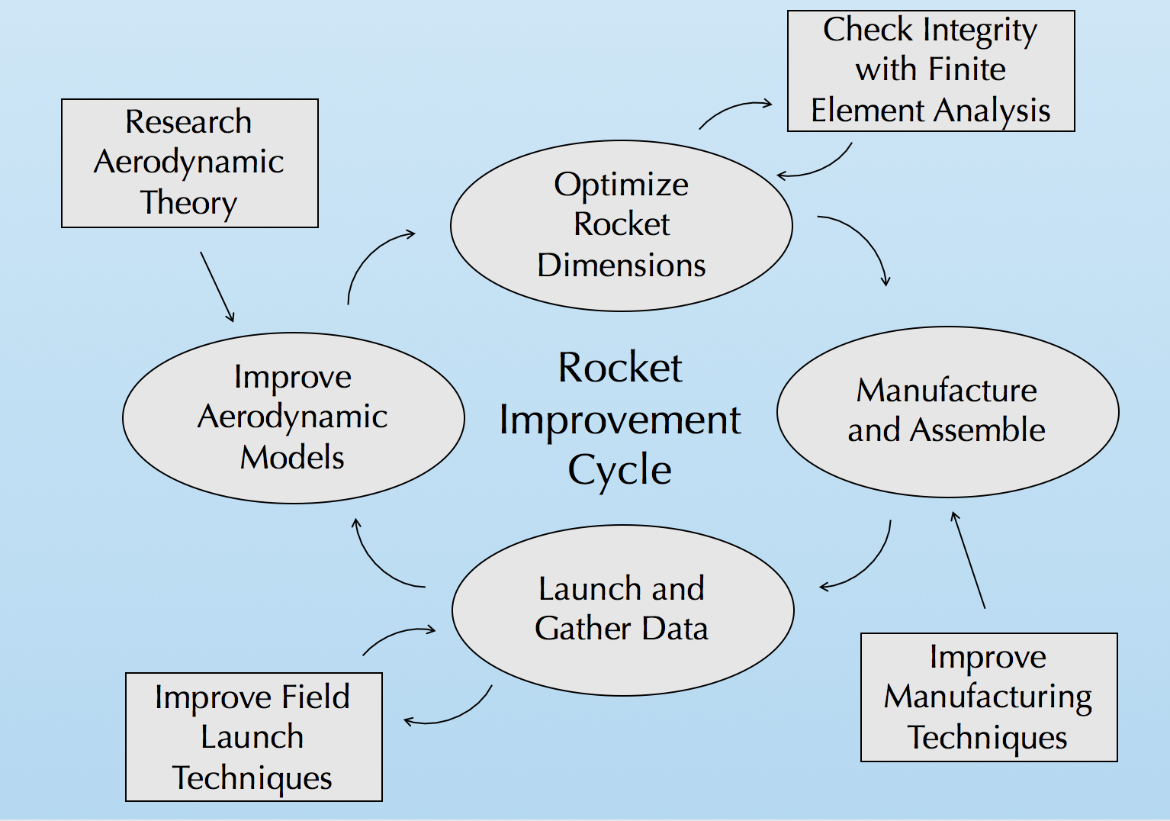

Figure 11. Improvement Cycle

Our team utilized an improvement cycle to ensure progression and improvement on each rocket iteration. The cycle begins with research of aerodynamic theory to enhance our aerodynamic models used for flight simulations. When the flight simulations are validated with experimental data, rocket dimensions are optimized for max altitude. This is done using a nonlinear optimization program in MATLAB. These dimensions are constantly checked with finite element analysis to ensure structural integrity with a minimum factor of safety of 3. The rocket is then manufactured with the optimal dimensions, while attempting to employ better techniques from last build. After the rocket is manufactured, it is launched, and data is gathered. We are always pursuing better launch techniques to ensure recovery of all components. The data from the flight is reviewed and compared to our flight simulations, where the process then repeats.

UNH SEDS is currently on its 8th iteration of this cycle, with a planned launch of *Aether VI* on Wednesday, May 9th 2018.

## Aerodynamic Models

Obtaining a trustworthy model for the trajectory of a given rocket is essential in rocketry design. It allows for a prediction of location and velocity of rocket at any given point in its flight path. This includes an estimation of the maximum altitude of the rocket, which allows us to quantify the quality of a given rocket design that is directly related to our primary goal.

An accurate model can also provide approximate landing distance from the launch pad for a given crosswind velocity. This essential in designing the recovery system of the rocket, as it confirms that the rocket will land within the launch field.

A number of commercial rocketry simulation programs currently exist, however many of them are pricy and made to be a “black box”. These programs have been proven to give accurate solutions, but there is typically no access to internal program to gain an understanding how these simulations are achieved. This is not desirable for SEDS, as achieving a fundamental understanding of the physics behind a rocket’s flight takes top priority.

Therefore, our team has created our own aerodynamic models using MATLAB. The program is essentially a numerical simulation of the rocket that calculates altitude and velocity changes over incremental time periods. This required creating accurate stability, thrust, drag, and atmospheric models that can be called upon at each time increment.

### Assumptions

1. The rocket is treated as a combined rigid body that separates at stage separation
2. Flow over the rocket is steady state with no vortices
3. The attitude of the rocket is constant throughout flight, with nose cone pointing up
4. Fins are flat plates with no cant angle
5. The rocket is axially symmetric
6. Significant drag components considered are base, pressure, and skin friction drag
7. The pressure drag component from the ogive nose cone is negligible, due to its aerodynamic geometry.
8. A rocket can be considered passively stable if it has a caliber above 1 [1]
9. Only pressure drag was considered after parachute deployment
10. Crosswind speed is constant for a given launch day
11. Deviation due to Coriolis effect of the Earth is negligible
12. Gravitational acceleration is constant

### Program Structure

#### Stability

In rocketry, caliber is a measure of the stability of the rocket. It is well known that the ideal caliber for a stable rocket is between 1 and 3. Caliber is calculated with Equation 1:

Equation 1

$$Caliber=\frac{C_{p}-C_{g}}{D}$$

D is the diameter of the rocket, $C_{g}$ is the distance between the tip of the nosecone to the *center of gravity* of the rocket, and $C_{p}$ is the distance between the tip of the nosecone to the *center of pressure* of the rocket.

The center of gravity is the average location of the mass of the rocket. This can be estimated by summing the center of gravity of each individual component of the rocket and dividing it by the total mass.

Equation 2

$$C_{g}=\frac{1}{m_{tot}}\sum_{i}{m_{i}x_{i}}$$

The center of pressure is average location of the pressure on the rocket. In other terms, it is the point where the total sum of a pressure field acts on the rocket. The is important to determine, as the total drag force vector is the value of this integrated pressure field acting through this point. Calculating the $C_{p}$ for a rocket design is outlined in a paper by Barrowman (1966) **[1]**

Fin design is the primary contributor to the location of the center of pressure. We decided to go with a trapezoidal model, mostly for ease of calculation. The trapezoidal fin model is also versatile; as triangular fins can be modeled when Ct is zero (see Figure 12). Square fins can also be represented as Xr goes to zero and Ct=Cr.

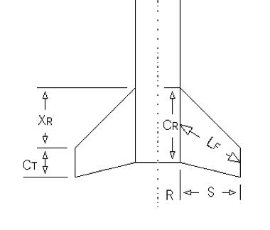

Figure 12 Trapezoidal Fin Model

The following equations are taken from Barrowman (1966) **[1]**. The approach uses force coefficients based on the relative geometry of the nosecone, body, and fins to approximate the average location of the forces.

Equation 3

$$C_{p}={(C}_{nn}*X_{n}+C_{nt}*X_{t}+C_{nf}*X_{f})/(C_{nn}+C_{nt}+C_{nf})$$

Where $C_{nn}$ is the force coefficient for the nose cone, which is experimentally found to be 2 for the ogive shape that we are using for our rockets. $C_{nt}$ is the coefficient that arises if the diameter of the rocket varies, and in our case it doesn’t so it equals zero. The X variables in the equation are the distances between the centroid of the shape and the tip of the nose cone. $C_{nf}$ is the coefficient that is affected by the fins, and is calculated as follows:

Equation 4

$$C_{nf}=\frac{4*Number of fins*{(\frac{S}{2*R})}^{2}}{1+\sqrt{1+\frac{2*L_{f}}{C_{R}+C_{T}}}}$$

Where all variables are defined in Figure 12

It is essential to make sure that the $C_{p}$ is at the very least aft of the $C_{g}$. If the $C_{p}$ was in front of the $C_{g}$, the rocket would be extremely unstable and any applied moment from cross-winds would flip the rocket. This form of instability is similar to instability of an inverted pendulum. Therefore, to drive the $C_{p}$ towards the aft end of the rocket, more stabilizing surfaces can be added to the aft end. This is why fins are typically located as far aft of the rocket as possible.

Stability is first calculated in the rocket simulation, as the rocket will not fly if it is outside of the 1-3 caliber range. For multistage rockets, caliber calculation is performed both before and after separation. Caliber also changes with respect to time due to mass loss as the propellant burns. This increases the caliber as the engine fires because it drives the center of gravity forward, as demonstrated in the *Aether IV* stability simulation (Figure 13).

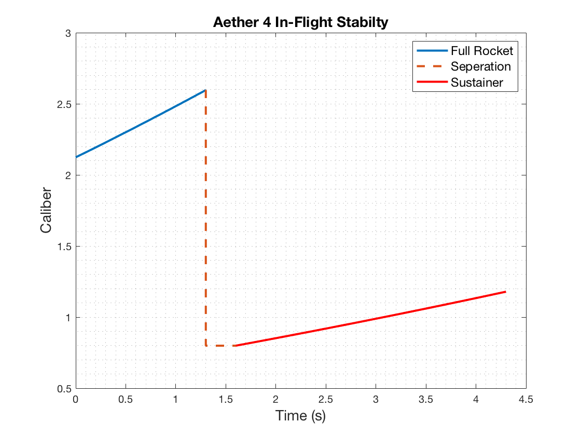

Figure 13. Aether IV Caliber

#### Acceleration

Starting from ignition on the launch pad, the program calculates the acceleration of the rocket at each time step. It accomplishes this by applying Newton’s 2nd law to the rocket: subtracting the aerodynamic drag force (D) and gravity from the engine thrust (T), and dividing by the mass at that instant.

Equation 5

$$a_{i}=\frac{T_{i}-m_{i}g-D_{i}}{m_{i}}$$

#### Thrust

The engine thrust is taken from thrust curve data, $T(t_{i})$. This is supplied by the engine manufacturer; however, we can also use experimental data from the STFR if we are testing a rocket with our competition engines.

#### Mass

The mass at a given time, $m_{i}$, is found by subtracting the total lost mass at that instant from the initial mass. Total lost mass considers the amount of propellant burned as well as mass lost from stage separation. Mass of propellant burned at a given time is found by multiplying burn time by the average burn rate of each engine.

Equation 6

$$m_{lost}={(t}_{i}-t_{ignition})(\frac{m_{full}-m_{empty}}{t_{burn}})$$

Where $m_{lost}$ is the expended propellant mass of a given engine, $t_{ignition}$ is the time at which the engine ignites, $m_{full}$ is the mass of the engine pre-ignition, $m_{empty}$ is the mass of the empty engine casing, and $t_{burn}$ is the total burn time of the engine.

#### Drag

The instantaneous drag, $D_{i}$, is calculated by calling a function called GetDrag. GetDrag calculates the combined drag force on the rocket, which is dependent on instantaneous velocity ( $v_{i})$ and height ($h_{i}$) and time ($t_{i})$.

Air density has a large effect on the resulting drag, and it changes a significantly as the rocket flies into the upper atmosphere. We incorporated an atmospheric model that incorporates the scale height of the Earth to find density at a given altitude. Scale height, $H$, is the vertical distance over which the density and pressure of the atmosphere fall by a factor of 1/e. **[2]**

Equation 7

$$ρ_{i}=ρ_{o}e^{-\frac{h_{i}}{H}}$$

Where $ρ_{o}$ is the air density at sea level (1.225 kg/m^3), and H is the scale height of the earth (8400 m). If $v_{i}<0$, then the parachute has deployed and the drag from each parachute is also included in the calculation.

At $v_{i}>0$, the function takes into consideration pressure drag, skin friction drag, and base drag on all rocket components and sums the drag forces to find the total instantaneous force of drag. As the booster body tube separates from the sustainer body tube the function corrects itself; no longer accounting for the full rocket length and two fin sets. To calculate skin friction drag coefficients, we use Reynold’s number ($R_{e}$) and surface roughness ($R_{s})$.

The following equations 8-12 for drag were taken from Barrowman, 1966 **[1]**.

Equation 8

$$R_{e}=\frac{vl}{}$$

The surface roughness was estimated using Table 1 and used to find the critical Reynold’s number $(R_{crit})$.

Table 1. Surface Roughness

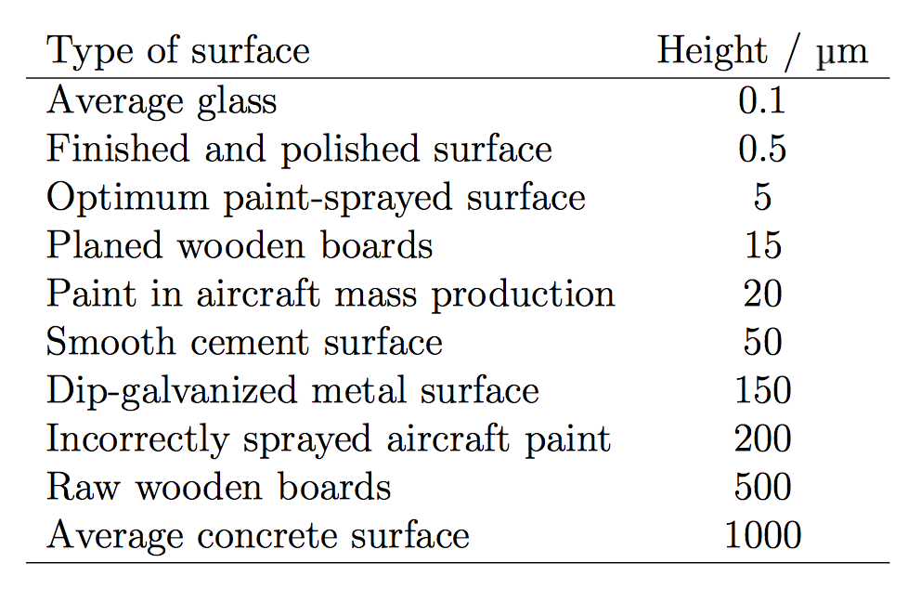

Equation 9

$$R_{crit}=51{(\frac{R_{s}}{L})}^{-1.039}$$

Using Reynold’s number and critical Reynold’s number, the coefficient of drag due to skin friction was calculated using Barrowman’s empirically derived formulas.

Equation 10

$$if R_{e}<{10}^{4}: C_{sf}=1.48x{10}^{-2}$$

$$if {10}^{4}<R_{e}<R_{crit}: C_{sf}=\frac{1}{{\left(1.5lnR-5.6\right)}^{2}}$$

$$if R_{e}>R_{crit}: C_{sf}=0.032{(\frac{R_{s}}{L})}^{2}$$

Compressibility effects were also taken into consideration for subsonic and supersonic speeds. Skin friction drag effects were found for the body tubes and fin sets.

For the specific geometry used, pressure drag effects on the nose cone were considered negligible. To find the coefficient of drag for the fins, the leading-edge angle of the fins and their frontal area were taken into consideration. Again, drag coefficients were found with Barrowman’s experimentally derived equations depending on Mach number.

Equation 11

$$for M<0.9: C_{D}=\left[{\left(1-M^{2}\right)}^{-0.417}-1\right]\cos^{2}\left(LEA\right)$$

$$for 0.9<M<1: C_{D}=\left[1-1.785(M-0.9)\right]\cos^{2}(LEA)$$

$$for M>1: C_{D}=\left[1.214-\frac{0.502}{M^{2}}+\frac{0.1095}{M^{4}}\right]\cos^{2}(LEA)$$

Finally, base drag was considered using the cross-sectional area of the body tube and relationships with current Mach number.

Equation 12

$$for M<1: C_{D}=0.12+0.13M^{2}$$

$$for M>1: C_{D}=\frac{0.25}{M}$$

The components of drag were then each calculated with the following drag equation using respective reference areas and drag coefficients.

Equation 13

$$F_{D}=C_{D}\frac{1}{2}v^{2}A$$

Total instantaneous force of drag was calculated from a summation of skin friction drag, pressure drag, and base drag.

#### Trajectory

From here the velocity and height can be found by simply integrating the acceleration and adding to the values at the previous time step.

Equation 14

$$v_{i}=v_{i-1}+∆t{*a}_{i}$$

$$h_{i}=h_{i-1}+∆t{*h}_{i}$$

A time step resolution of $∆t=0.01$ was found to be acceptable, as the results converged to a consistent solution. Figure 14 demonstrates a completed simulation for the *Aether IV* design.

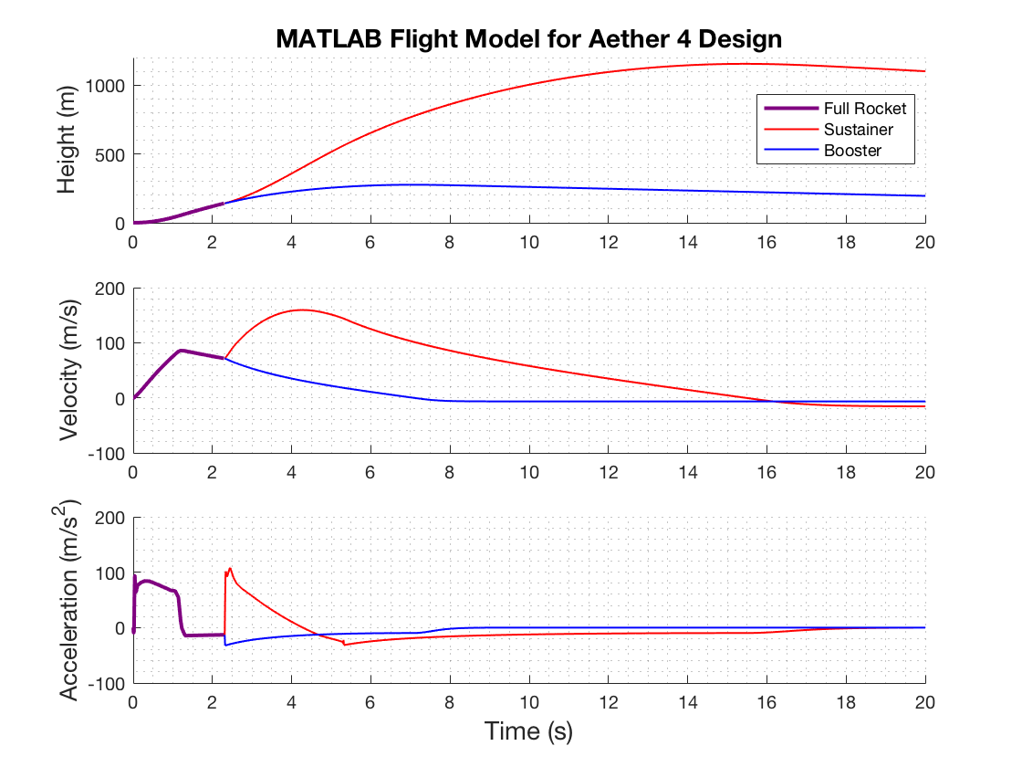

Figure 14. Aether IV Launch Simulation

Landing distance from launch pad, $D_{LZ},$ can then be estimated as follows:

Equation 15

$$D_{LZ}=t_{land}v_{crosswind}$$

Where $t_{land}$ is the time the rocket hits the ground, and $v_{crosswind}$ is the estimated wind speed on the day of launch take from weather.gov.

### Model Verification

The MATLAB model can then be verified by comparing simulated results to the experimental results for a given design. Additionally, we modeled the flight our rockets with OpenRocket. OpenRocket is a widely accepted, open-source rocket simulation program which performs similar calculations to our MATLAB model. We create a 2D model of our rocket design on OpenRocket with accurate component weights and dimensions, and then compare the program’s simulation results to our own. Significant data points to compare are the apogee, descent velocity, and landing distance. Verification using the *Aether IV* design can be seen in Figure 15.

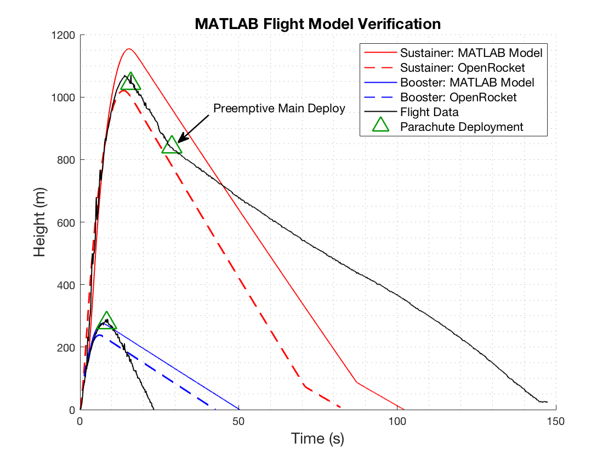

Figure 15: Model verification using Aether IV rocket

The booster deployed its parachute successfully and reached the ground safely, but it fell much faster than predicted. This is because of our estimations used for the parachute in our drag function. Additionally, during test the main deployed pre-emptively, causing the rocket components to drift longer and slower. Since these tests, we have worked to create a tighter fit between the nose cone and e-bay, while allowing for a loose enough fit that the ejection charge is able to separate the components.

The apogee results for both simulations and the experimental data are shown below in Table 2.

Table 2. Aether IV Apogee Predictions

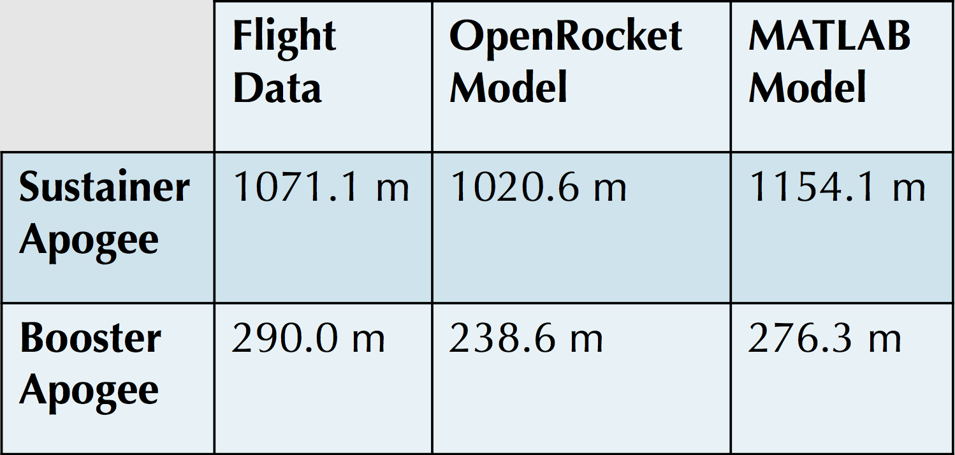

Given our assumptions and limitations on the accuracy of our simulations, the modelled trajectories were decent projections of the experimental flight data. There are many uncertainties that we cannot account for in our simulations, such as varying wind speeds at altitude, friction between the lugs on the rocket and the launch rail, and increases in base drag while the engine is not firing; to name a few. The booster apogee was more accurately predicted by the MATLAB model but the sustainer apogee was better simulated by OpenRocket. For the typical unpredictability of a rocket launch, we were satisfied with our estimations for apogee. Moving forward, the focus for *Aether V* and *Aether VI* has been on successfully triggering events with the flight computer; both main parachute deployment and sustainer engine ignition.

## 

## Nonlinear Optimization

Once the aerodynamic MATLAB models have been verified to be reasonably trustworthy, optimal dimensions for a given rocket configuration can be found by using the built-in MATLAB nonlinear programming solver, *fmincon*. This solver finds the minimum of a nonlinear multivariable function, while also being constrained by linear and nonlinear relations. It does this using an interior-point algorithm that, in simplified terms, constantly varies each variable and follows the gradient of the solution.

To utilize this solver, all of the aerodynamic models had to combined into a single function. The inputs of this function are the various dimensions of each component of the rocket and the output is the simulated maximum altitude.

The results of the solver applied to our *Aether VI* design can be seen in Figure 16.

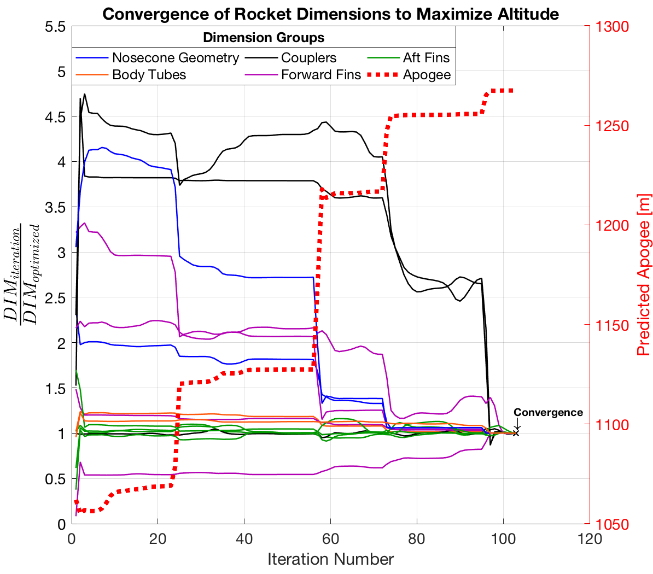

Figure 16. Optimization of Aether VI Dimensions

The dotted red line shows that approximately 200 m was added to the apogee the initial guess of the dimensions after optimization. The solid colored lines demonstrate how every dimension that is being varied converges to a single set of dimensions that results in the highest predicted apogee. This particular optimization had 104 iterations before it converged on a function result that is non-decreasing in feasible directions. Specifically, the amount of change from the final iteration was below the stop-tolerance of the program.

### Constraints

The stability model is used as a constraint in this solver. The relation between rocket dimensions and stability is implemented such that the final solution must also have dimensions that result in an initial caliber of 1.5, both at the launch pad and after stage separation.

Manufacturing limitations dictate the upper and lower bounds for each rocket dimension. These include limits for coupler tolerances, required clearance between fins and motor, and the thickness of available materials.

### Finite Element Analysis

The final dimensions are then used to build 3D models in Solidworks and perform finite element analysis to confirm structural integrity of parts that are prone to failure, such as the engine centering ring seen in Figure 17. A factor of safety of 3 is typically used in aerospace vehicles **[3],** so this is the minimum we use to ensure structural integrity during flight.

A close up of a logo

Description generated with high confidence

Figure 17. Centering Ring FEA

If the factor of safety falls below 3 for any of the parts, the optimization program must be reconfigured and reran to get a new set of dimensions. Typically, this means adjusting the upper and lower bounds of certain dimension to ensure that there will be more material on the part on the next set of optimized dimensions.

## Model Rocket Class Iterations

### Model Rocket v1

Launched on 2/17/18

Rocket v1 was a single stage cardboard rocket with wood fins and a plastic conical nose cone. The body tube inner diameter is 38 mm and utilized a G54 engine. The objective for this rocket was to successfully manufacture, launch and recover, with little concerns of performance. After the build it was discovered the nose cone was the incorrect size; resulting in the body tube outer diameter being larger than the nose cone outer diameter. This is not optimal as it will induce much greater drag. During ignition, the engine fell out of the body tube due to no engine retainer. This resulted in a failure to launch. The two bolts used to hold the engine in place deformed the body tube, therefore it was concluded the centering rings must be used moving forward.

### Model Rocket v2

Launched on 2/24/18

Rocket v2 was constructed with the intent to fix the problems from v1. The rocket had the same overall structure as v1, with an implementation of a proper sized nose cone, correct engine detainment and centering rings. The goals for v2 were the same as v1 with an emphasis on launch. The launch was successful, and the flight followed a straight and stable trajectory. Recovery was unsuccessful due to the lack of visibility through the clouds. The rocket was lost and it was unclear if the main parachute deployed at apogee.

## 

## Aether Class Iterations

### Aether I

Launched on 3/19/18

The *Aether* class iterations utilize dual parachute deployment through the use of an electronics bay rather than an engine ejection charge. The goal for *Aether I* is to successfully launch a single stage rocket with parachute dual deployment. *Aether I* consists of 54 mm diameter cardboard body tube with wood fins, an ogive nose cone and the same 29 mm engines utilized in for v1 and v2. Launch was successful with a straight and stable trajectory. The altimeter read and apogee 550 meters when open rocket predicted an apogee of 330 meters. This discrepancy is most likely due to user error of open rocket simulations. At apogee the drogue deployed, and the aft body tube separated from the coupler and body tube, resulting in free fall. The drogue was tangled during decent and the main parachute failed to deploy at 150 meters like it was supposed to. The aft body tube had a hole located at the bottom between the centering rings. The reason for the failure is suspected to be because the shear pins that are supposed to keep the body tube, coupler and electronics bay aligned were not removed, resulting in improper separation.

### Aether II

Launched on 3/26/18

*Aether II* was designed and manufactured with the intent to fix the problems from *Aether I*. It is a remake of *Aether I* with all the same characteristics and dimensions. The goal of *Aether II* for successful dual deployment and recovery. Specifically, shear pins must be removed so proper separation can occur, the drogue must unfold correctly and main parachute ejection charge should occur at 150 meters. Launch was successful, except trajectory was unstable resulting in rocket wobble. This can be fixed with better fin alignment. Drogue and main parachute activated correctly, however it was stuck in a tree. This is tough to control as the launch site is not as large as desired. To fix this we could deploy main parachute lower and potentially a smaller drogue, producing less drift.

### Aether III

Launched on 4/9/18

*Aether III* was the first attempt at a multistage rocket. The rocket was 54 mm in diameter, utilized wood fins, an ogive nose cone, a G54 booster engine and a G125 sustainer engine. The fins were aligned using a fin alignment tool to prevent the roll of the rocket. A lower parachute deployment height was selected to prevent drift. The goal is to successfully launch a two-stage rocket with proper dual deploy. For launch, both the booster and sustainer fired correctly, the booster parachute deployed and was recovered successfully. The sustainer parachute did not deploy due to incorrect packing and insufficient black powder charge. The electronics bay and nose cone were lost in the forest, resulting in no experimental data. Due to this loss, a Telemega GPS was acquired to prevent the loss of rocket and electronics bay.

### Aether IV

Launched on 4/13/18

*Aether IV* was designed and manufactured to improve on the mistakes made from *Aether III*. *Aether IV* is the same design as *Aether III* except implementing a blue tube body, fiberglass fins and fiber glass centering rings. Fiber glass is a stronger more aerodynamic material than wood. Black powder was calculated, measured, and tested to ensure the charge was powerful enough to deploy the parachutes. During launch, the booster fired with the trajectory changing angle mid-flight. The booster was recovered successfully, however the sustainer never ignited. The sustainer did not ignite because an improper ejection setting was selected using the new GPS system. The drogue parachute could not be fully deployed because the igniter was shorter than the Kevlar chord, preventing full separation. After flight, it was concluded that components such as centering rings and fins need to be milled; not sanded by hand. The more precisely the rings are the machined the easier it is to make the engine concentric with the body tube.

### Aether V

Launched on 4/22/18

*Aether V* utilized the salvaged components from *Aether IV* to attempt a relaunch with proper sustainer ignition. The Booster stage was remade because it was damaged, this time using a fin mold to evenly apply epoxy. The fins and centering rings were cut using a mill for better precision. The sustainer ignition wire was lengthened so the drogue can deploy properly. Testing was conducted to ensure the sustainer and booster ejection charges would ignite and parachutes would deploy. Better parachute folding techniques were employed to prevent tangling. Booster launch was successful, however the sustainer failed to fire. It was concluded that the ignition failure was due to an igniter short. To fix this we started buying igniters rather than making our own.

# DETAILED DESIGN

## Aether VI

Planned Launch Date: 5/9/18

*Aether VI* will be very similar to *Aether V,* and we are focused on achieving consistent ignition and parachute deployment. Since our homemade ignitors can no longer be trusted, high-grade firework ignitors were purchased. Also two parachutes were purchased that were made specifically for rocketry. The material is much thinner and does not hold its folded shape as easily as nylon does. The booster from *Aether V* will be reused, and a new sustainer body tube was made.

The following drawings are a sample of the most current optimized dimensions for various components. These dimensions will be used in *Aether VI* construction.

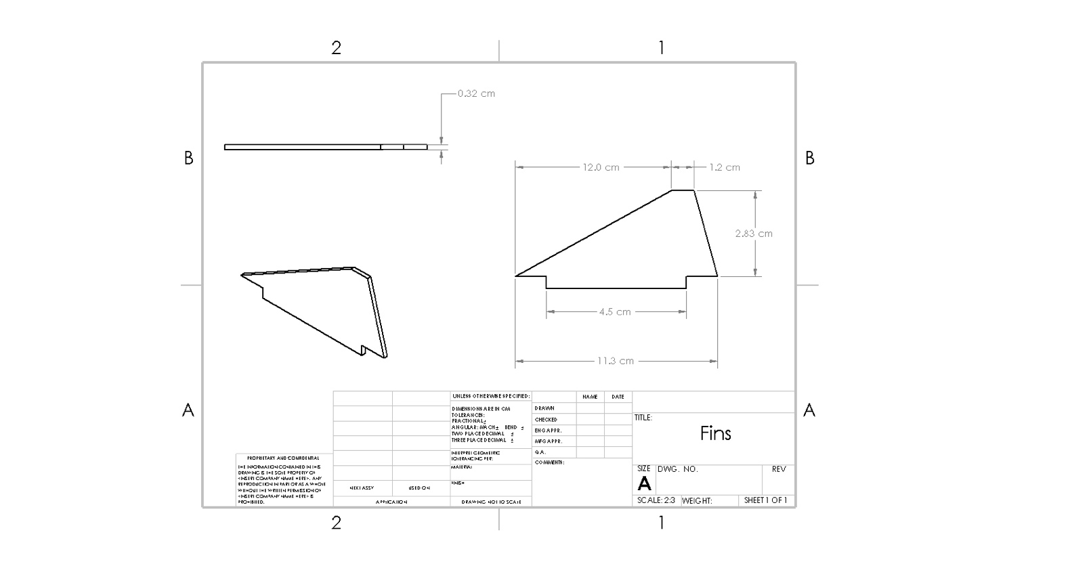

Figure 18. Booster Fins

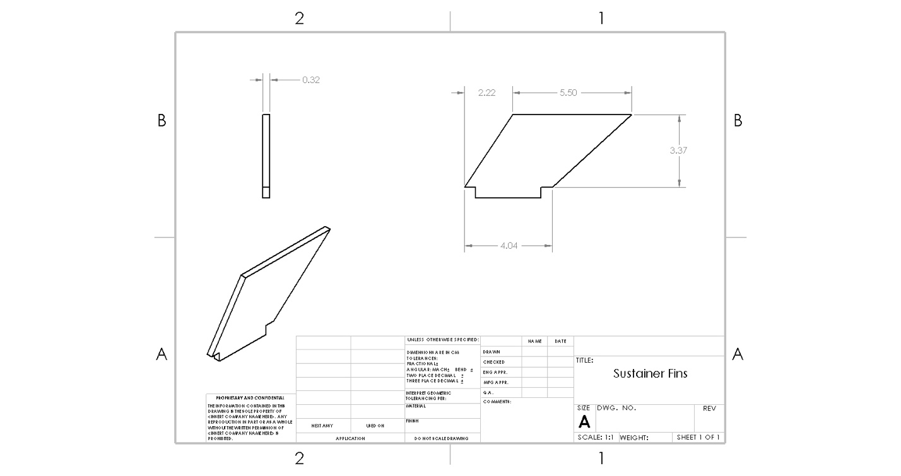

Figure 19. Sustainer Fins

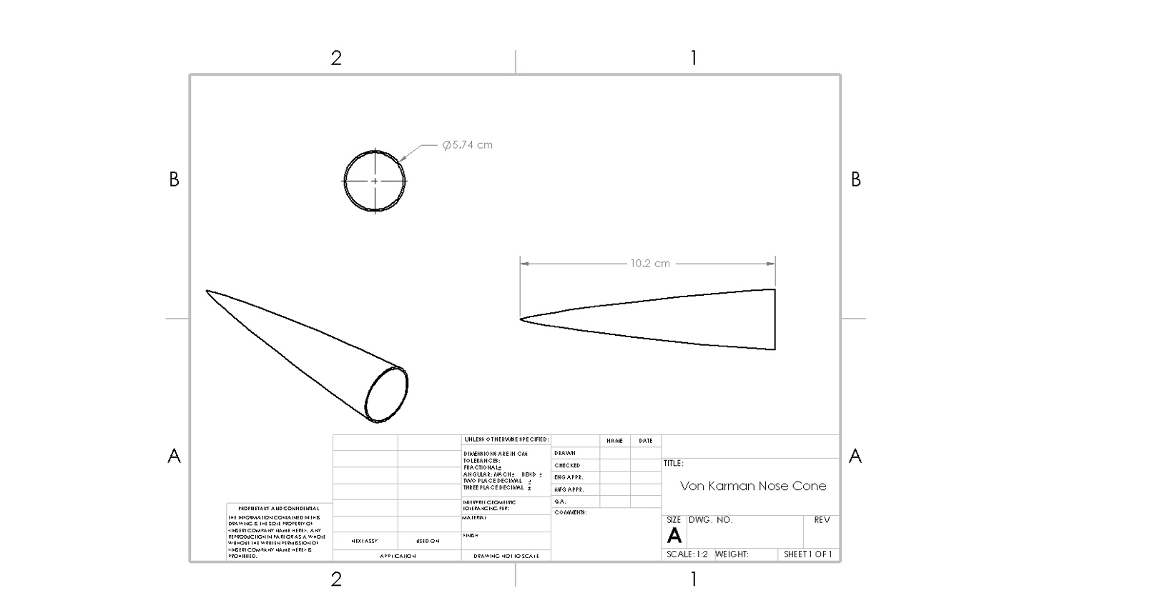

Figure 20. Nose Cone

# BILL OF MATERIALS



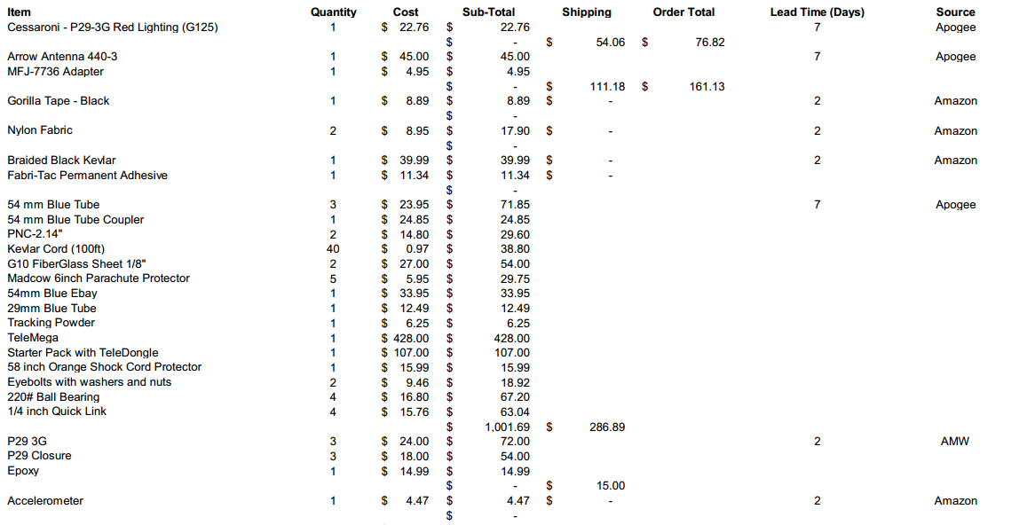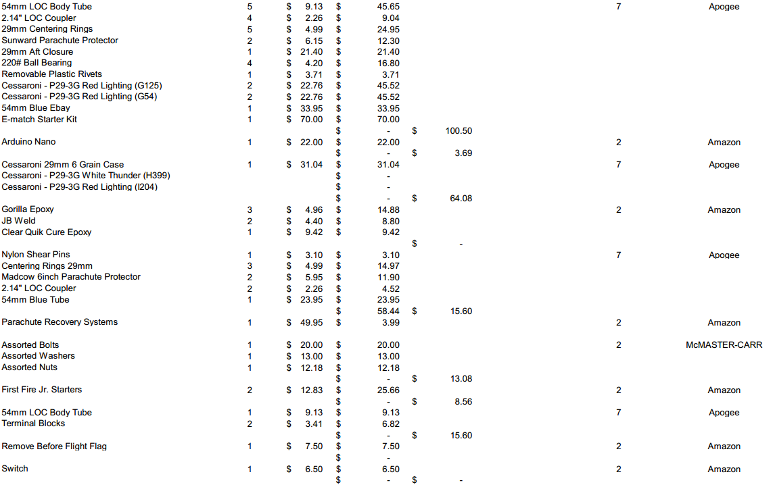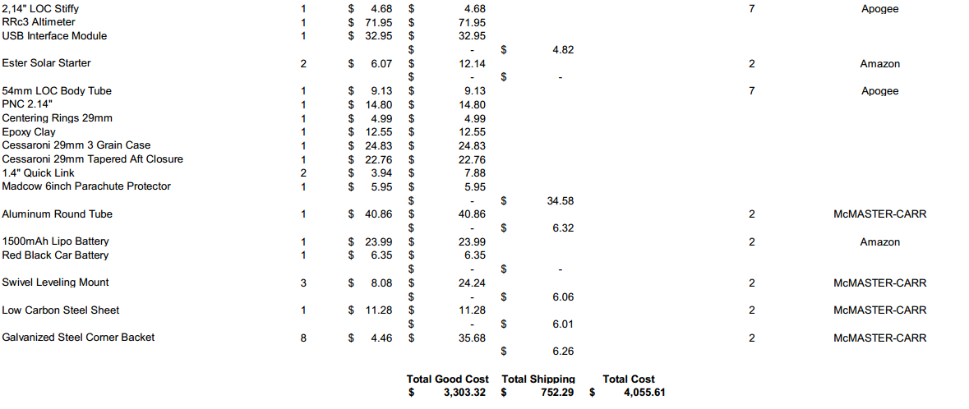

# 

# APPENDIX

## References

[1] Borrowman, J. S. (1966). The Theoretical Prediction of the Center of Pressure. NARAM -8. NASA.

[2] *Definition of Scale Height*. (n.d.). Retrieved from Astronomy Education at the University of Nebraska: <http://astro.unl.edu/naap/scaleheight/sh_bg1.html>

[3] Burr, A and Cheatham, J: *Mechanical Design and Analysis, 2nd edition*, section 5.2. Prentice-Hall, 1995